**Airport Simulator**

**Group 8**

**Requirement Specifications**

By

Ameya Babhulgaonkar

Manish Singh

Ruturaj Patil

Shubham Bodane

Utkarsh Saraswat

Vivek Shete

Contents

1. Problem Statement: 3

2. User case 3

3. Primary requirements for airport design 3

4. Assumptions: 4

5. Functional Requirements: 5

6. Non-Functional Requirements: 6

7. Technical Specifications 6

8. Use Case 7

9. Flowchart: 8

# 1. Problem Statement:

We are responsible for designing a new airport. One of the key decision is to decide how many gates the new airport should have. This decision depends on how many flights the airport can handle safely without congestion. We have to simulate airport traffic (holding, take off, landing, scheduling, emergency lands). The parts of the traffic control simulation system that you write may be reused later for real traffic control system for the same airport.

2. User case:

Government of India wants to build an Airport for Tier 1 city.

3. Primary requirements for airport design**:**

Requirement analysis for designing and construction of an airport includes extensive survey of land, demographics, environment, climate. Detailed description of the requirements is enlisted below.

1. City/Location type and its demographics:
2. Character of soil and meteorology of the location: Type of soil present in the area will decide architecture and material required used for the construction of the airport including runway, parking area, terminal. Further the design should also take consideration of possible natural disasters like earthquake, flood, cyclone etc.
3. Wind rose diagram of the location: Atmospheric flow of winds have major influence on the dynamics of the flight. Wind rose diagram is the standard used to carry out wind survey for any construction project. In our case, the orientation of runway(s) will be decided based on the direction and the magnitude of wind flow over the duration of a year.
4. Climate and geographical topology of the location: A pleasant, clouds free environment should be ideally preferred for the location of the airport. Besides climate, the terrain of the location also matters. A plain surface will always be a preferred location of the airport which is free from any mountains, hills, plateau.
5. Environment and vicinity of the residential areas.
6. Details regarding traffic and flight parameters (types of flight)
7. Number of arriving and departing flights.
8. Flight parameters for each flight.
   1. Passengers capacity.
   2. Wing Span.
   3. Weight.
   4. Time taken by flight from runway to gate.
   5. Off-boarding time.
   6. Standing time (including fuel fill-up and maintenance time).
   7. Onboarding time.
   8. Time taken by flight from gate to runway.
   9. Fuel capacity (in case of emergency landing).

# 4. Assumptions:

|  |  |  |
| --- | --- | --- |
|  | City | Pune |
|  | Population (Pune city) | 3.12 million |
|  | Average elevation of sight | 592 meters |
|  | Wind rose diagram | C:\Users\vqmmx3\Downloads\pune windrose.png |

# 5. Functional Requirements:

|  |  |  |
| --- | --- | --- |
| **Sr No** | **Requirements** | **Priority** |
|  | The system should be able to come up with number of gates the airport should have so that there will be no congestion. | Required |
|  | In case of emergency, the system will be able to determine how many emergency flights it can accommodate at a given situation. | Required |
|  | There will be provision for feeding information mentioned in section 3.6. | Required |
|  | Graph representation of number of gates plotted against number of people, number of flights. | Desired |

# 6. Non-Functional Requirements:

|  |  |
| --- | --- |
| **Sr No** | **Requirements** |
|  | Modularity:  1. System will be modular so that it can be further extended.  2. Modules can be reused in any other application wherever applicable. |

# 7. Use Case

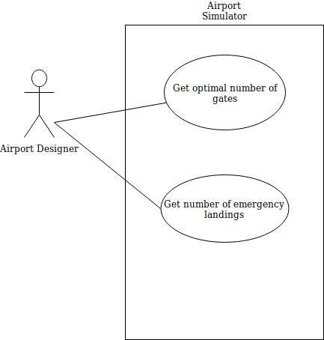

# 9. Flowchart:

